0

Institute for Sustainability Africa

Sustainability Reporting Compliance

by Public Listed Mining Companies

in Zimbabwe:

An Evaluation Against Stock Exchange Requirements.

Supported by:

Institute for Sustainability Africa

Sustainability Reporting Compliance by Public Listed Mining Companies in Zimbabwe:

An Evaluation Against Stock Exchange Requirements.
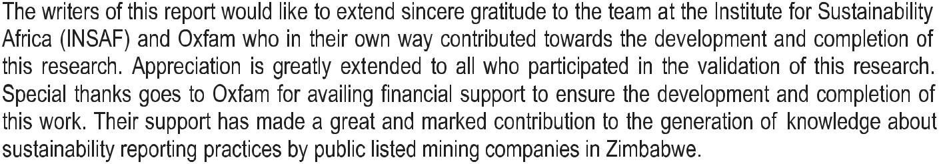
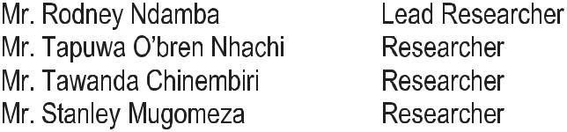

3

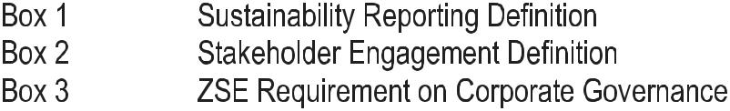
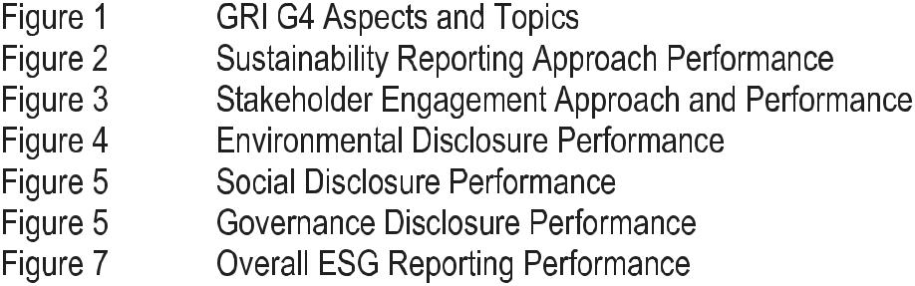
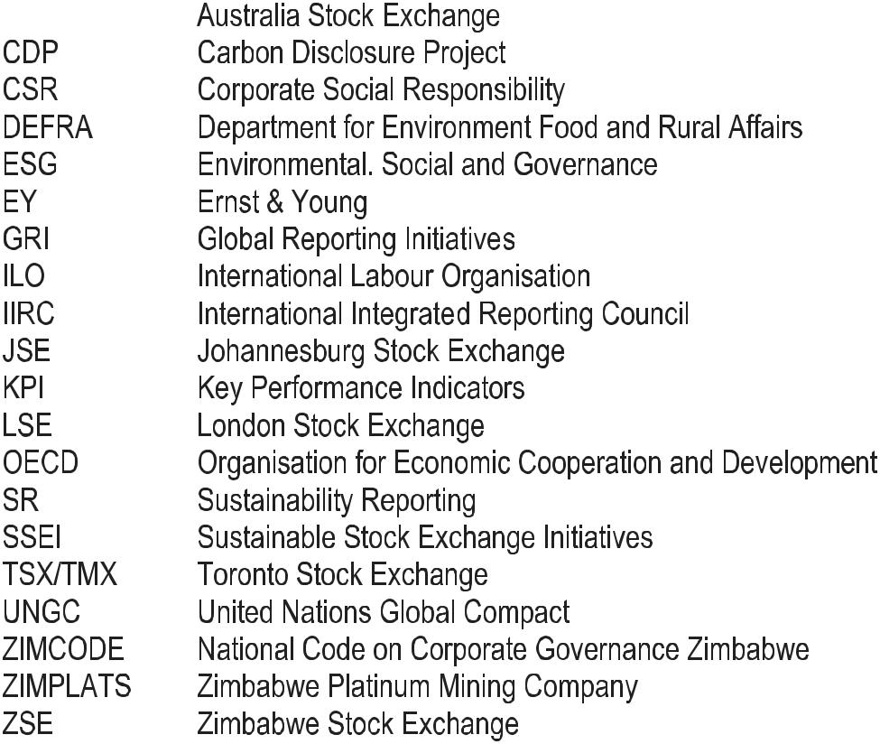

5

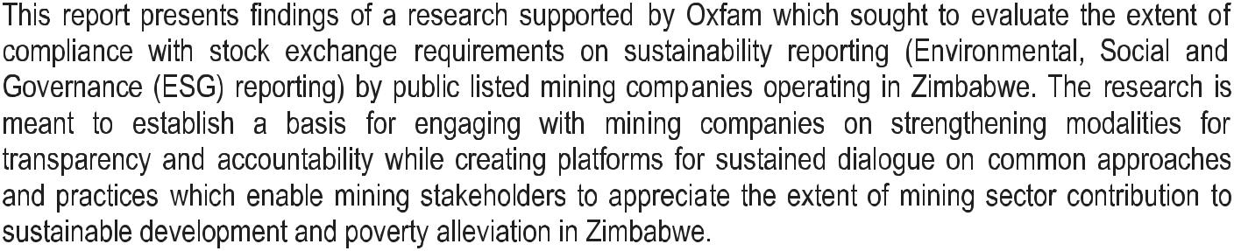
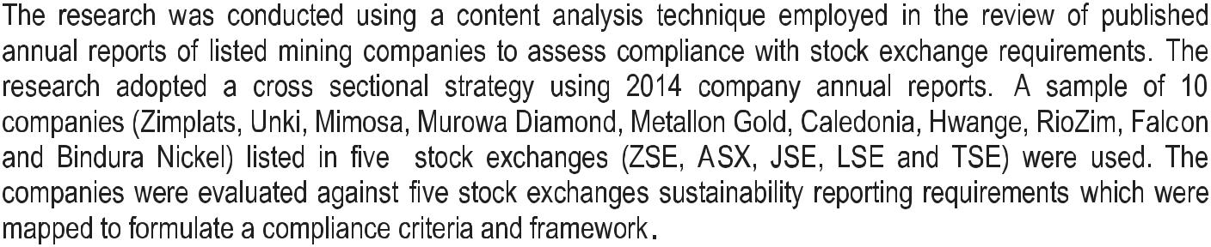
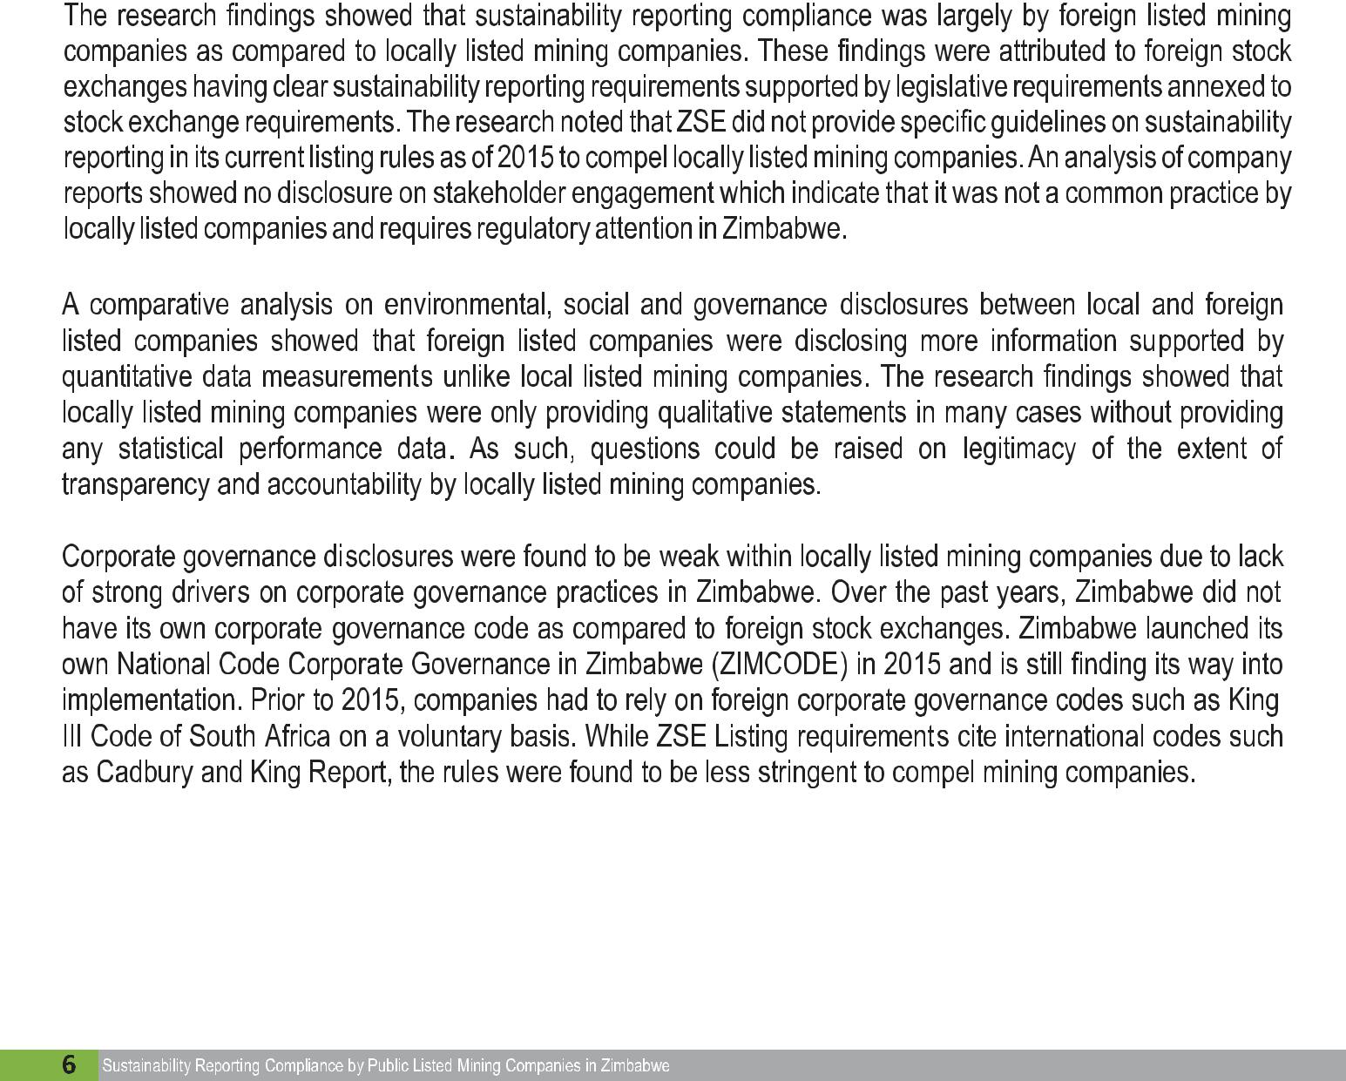
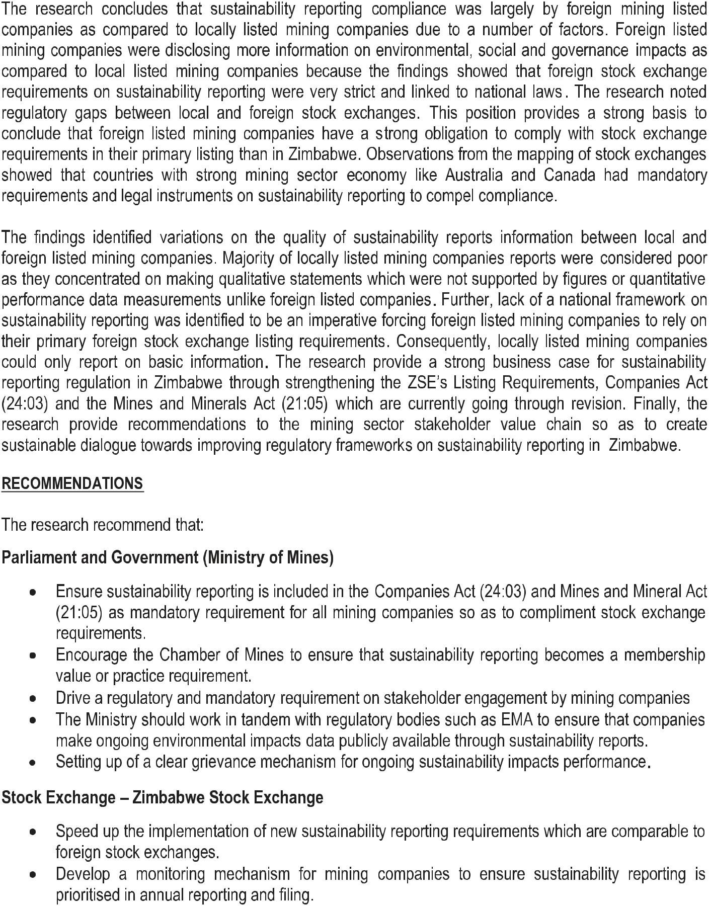

7

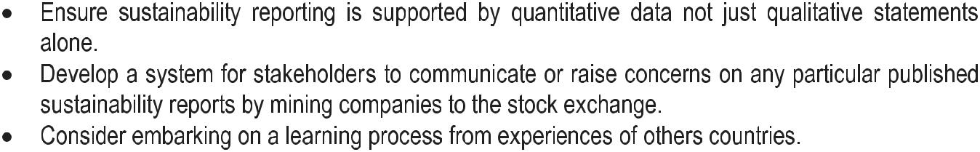
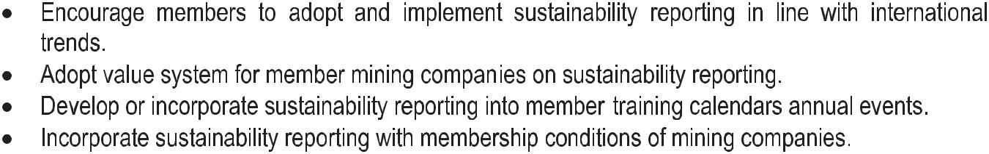
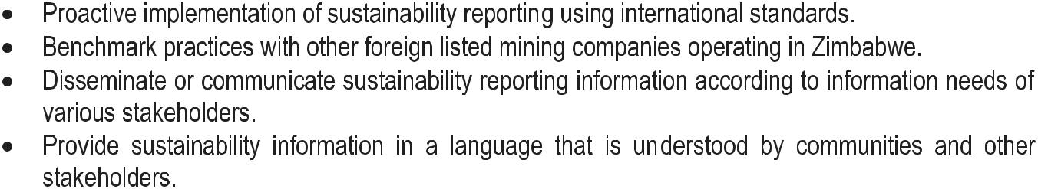
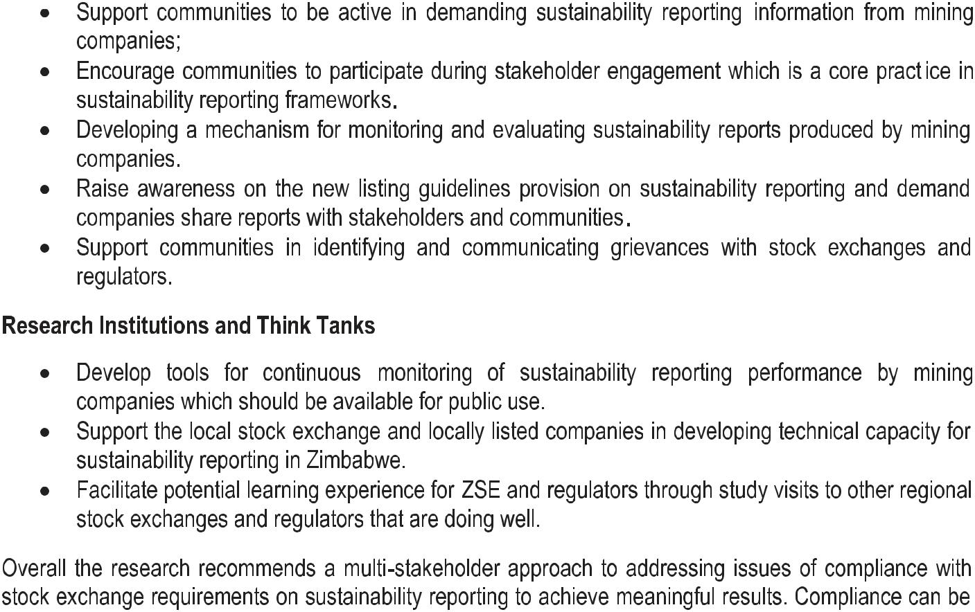

9

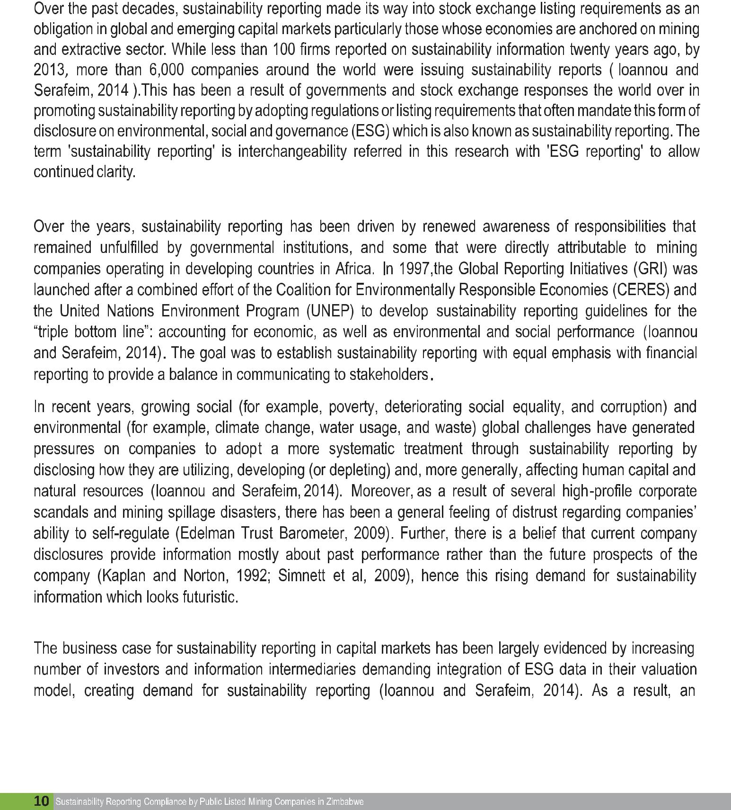
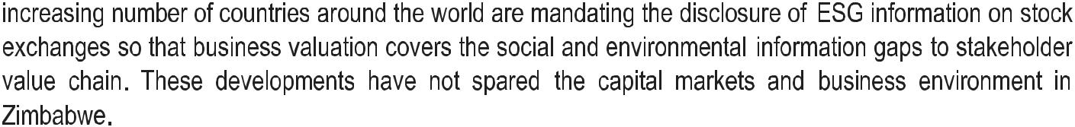
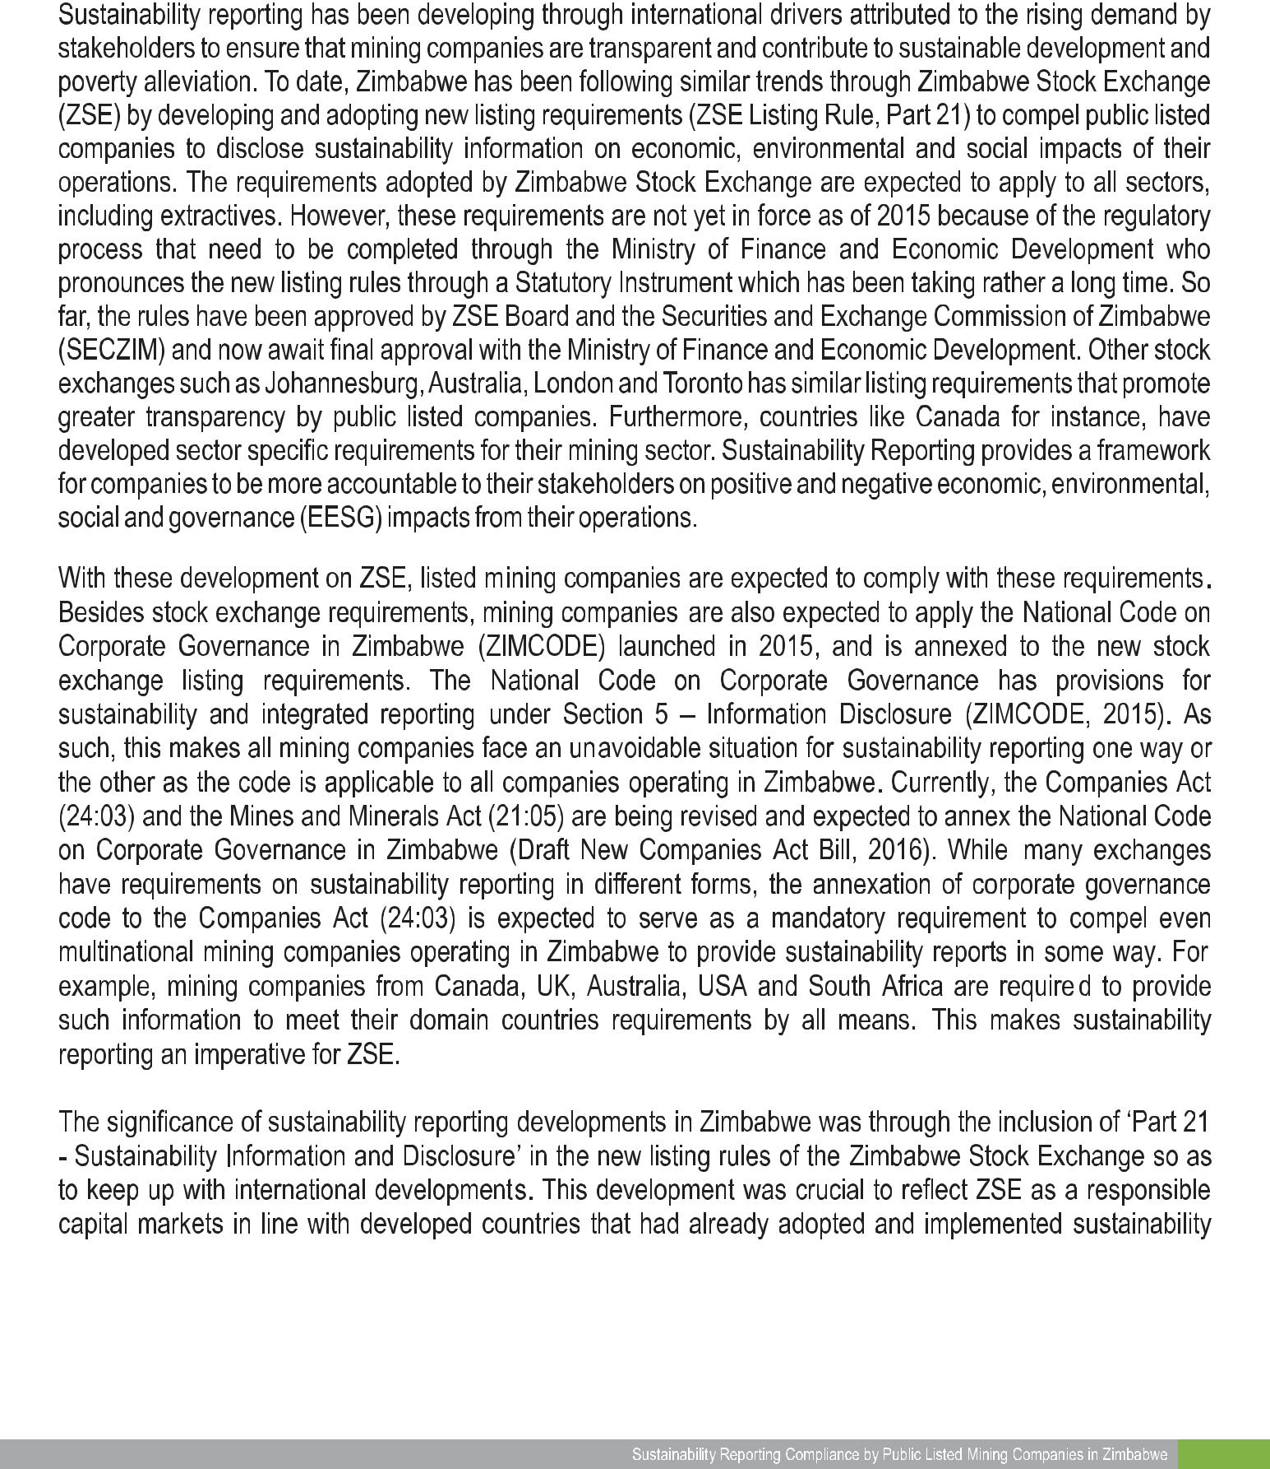

11

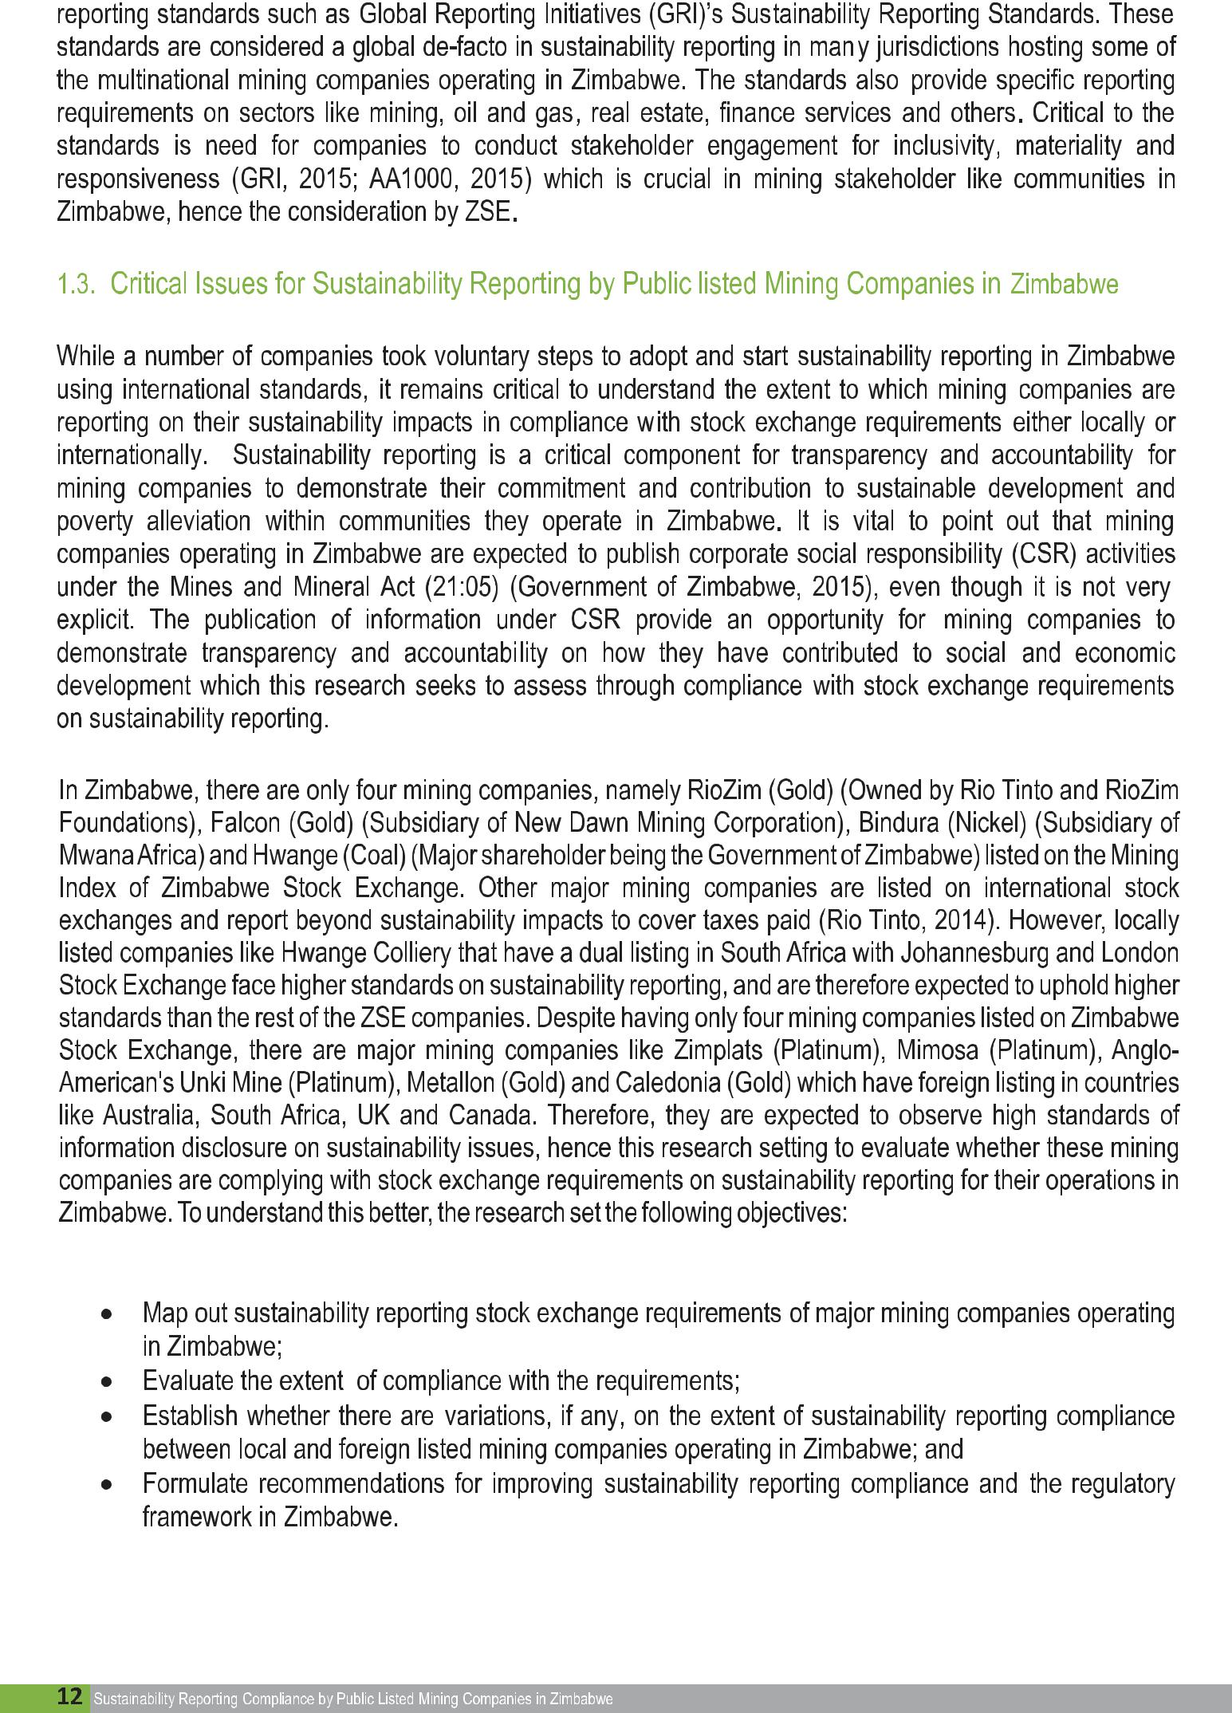
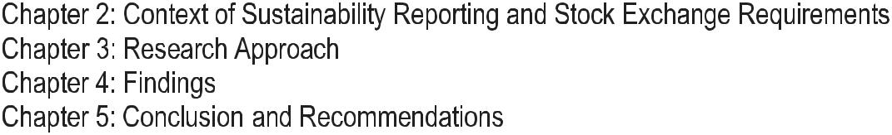
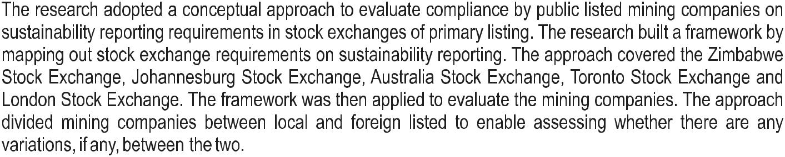

13

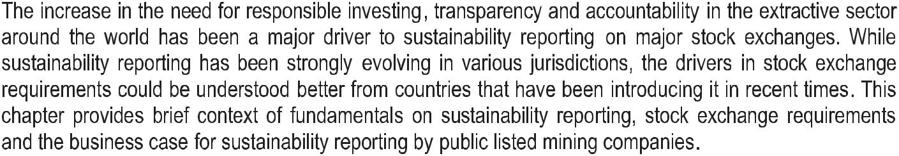
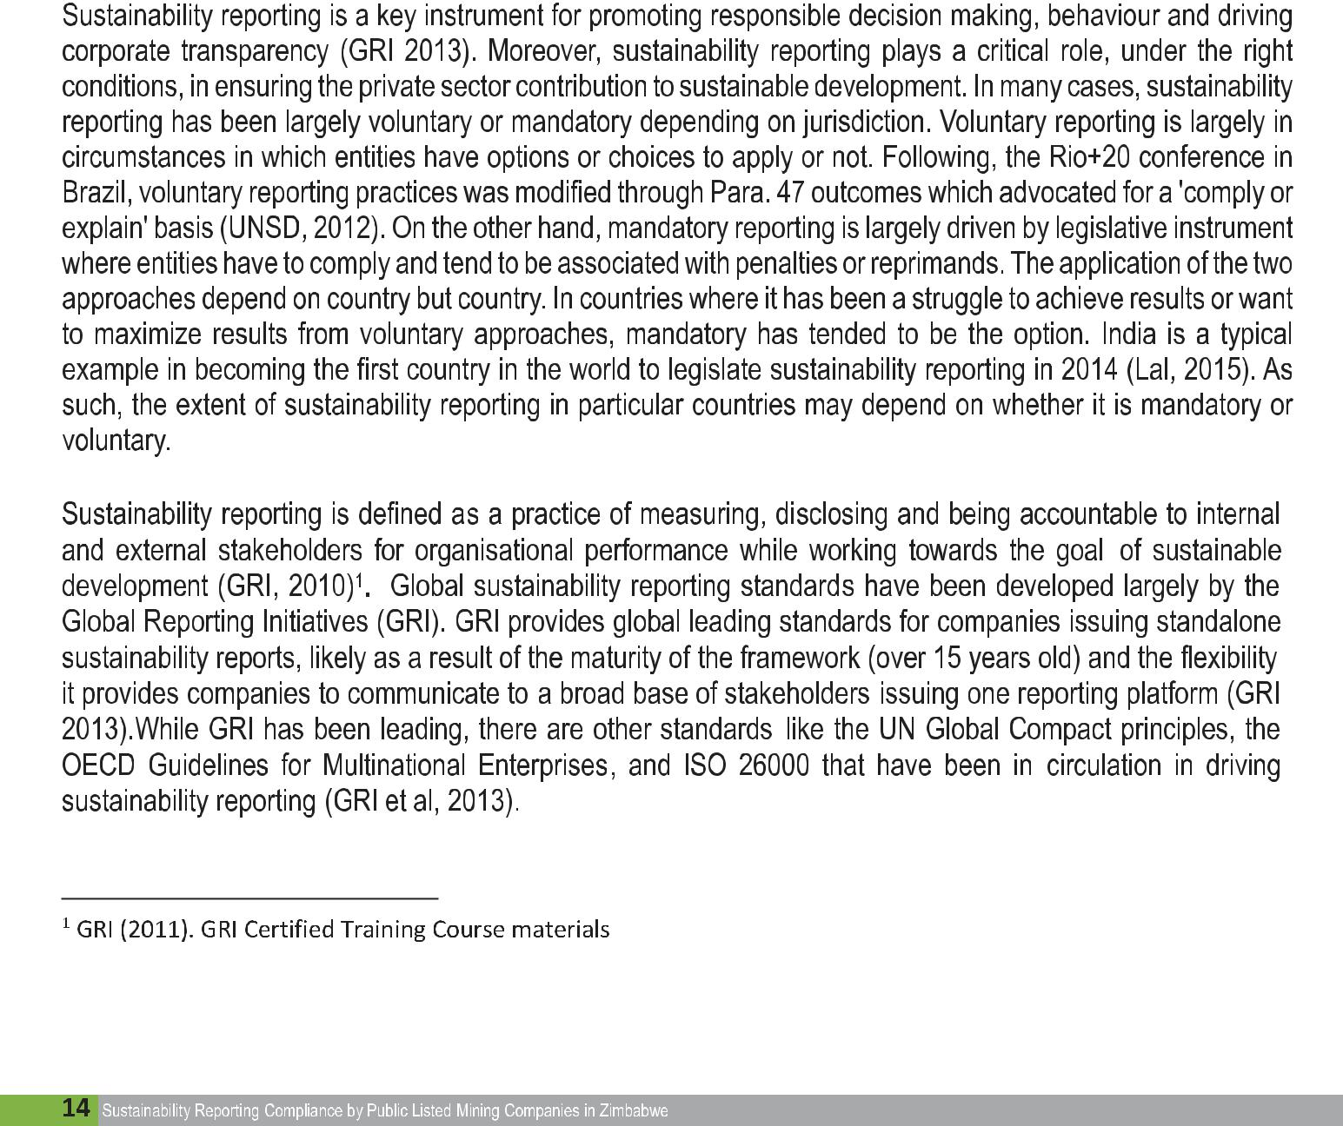
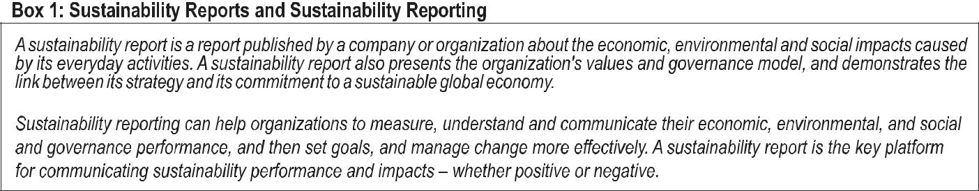

Source: www.globalreporting.org
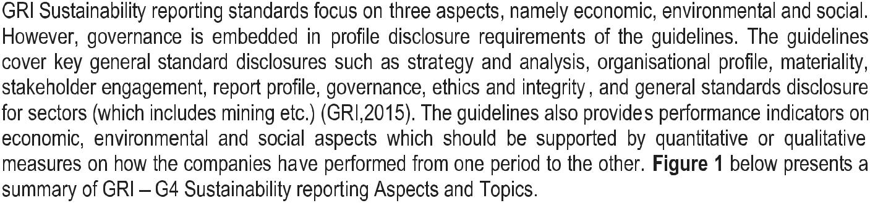

Figure 1: GRI G4 Aspects and Topics
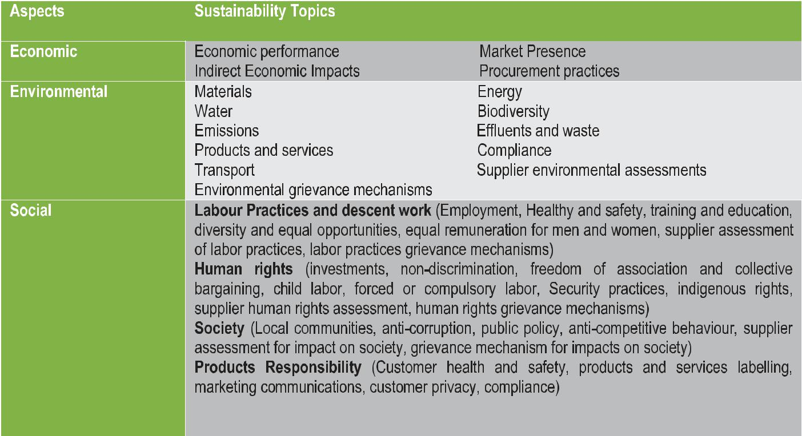

Source: GRI (2015), G4 Guidelines
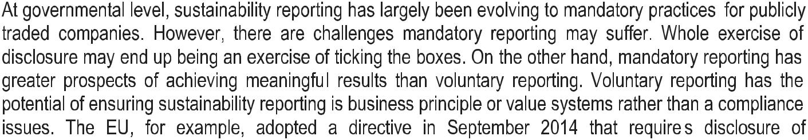

15

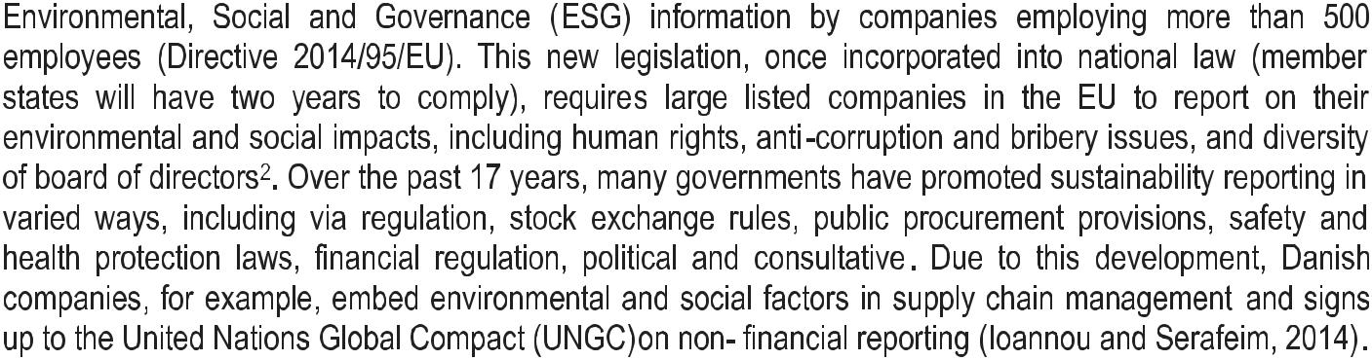
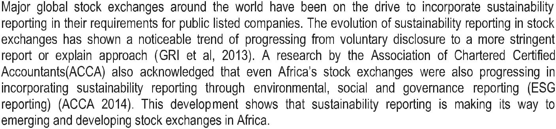
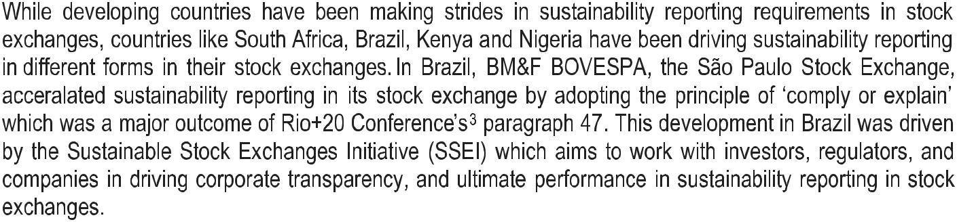
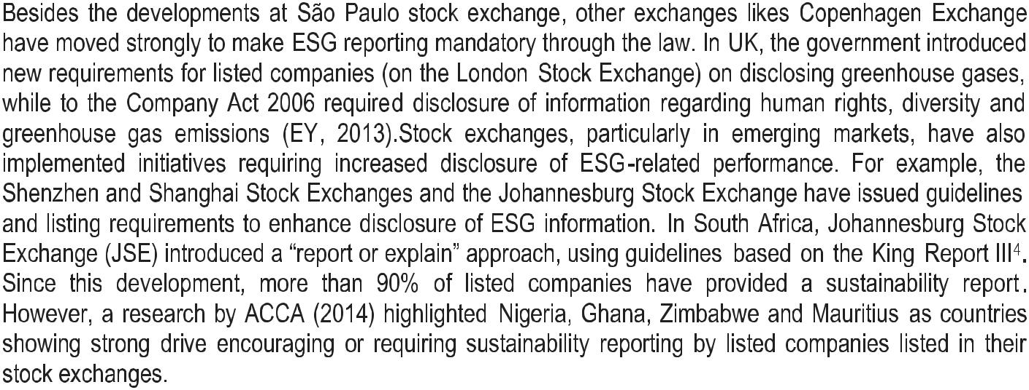
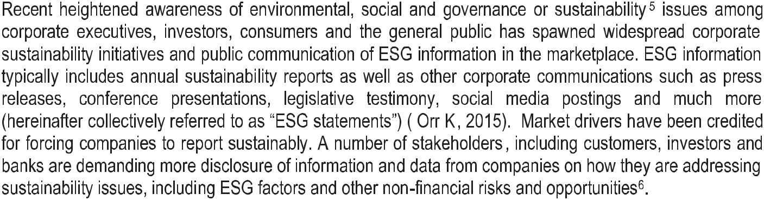
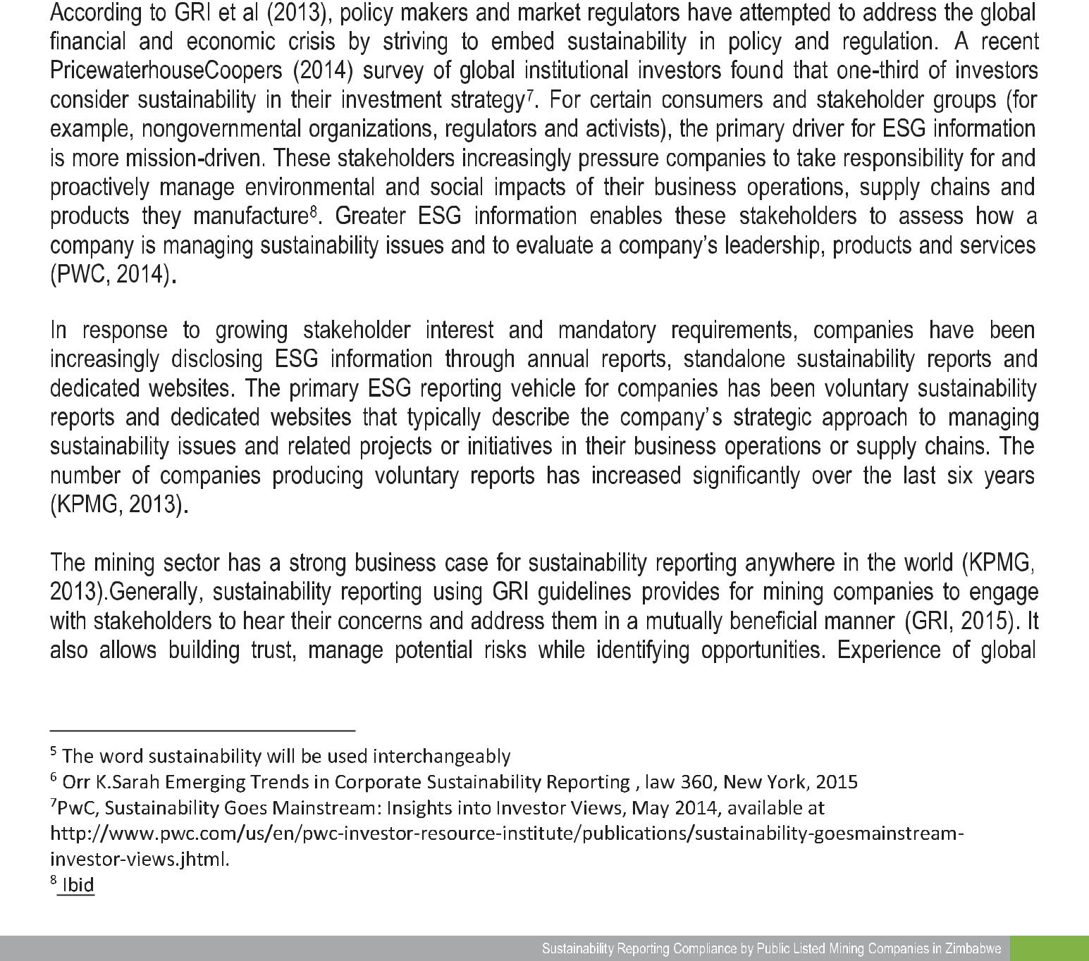
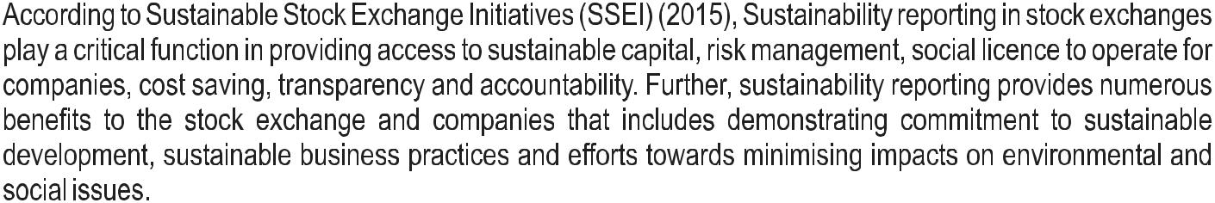

17

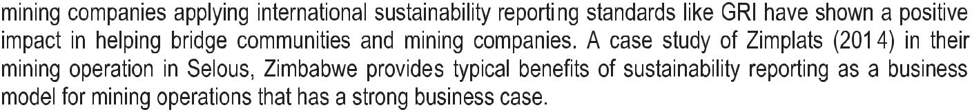

Box 2: Case study of Zimplats
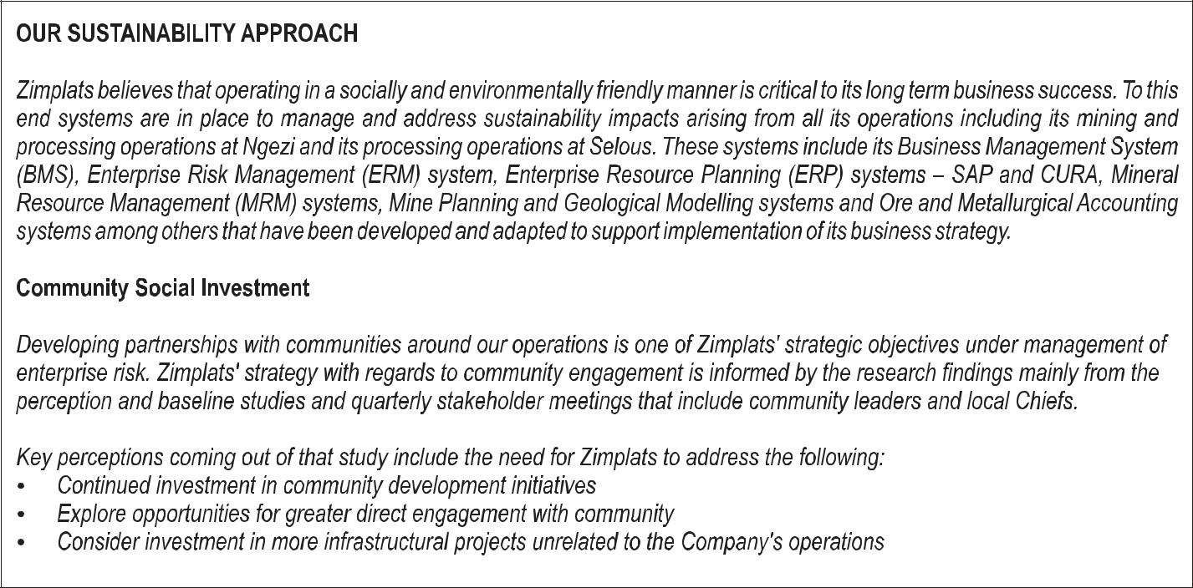

Source: Zimplats Annual Report 2014
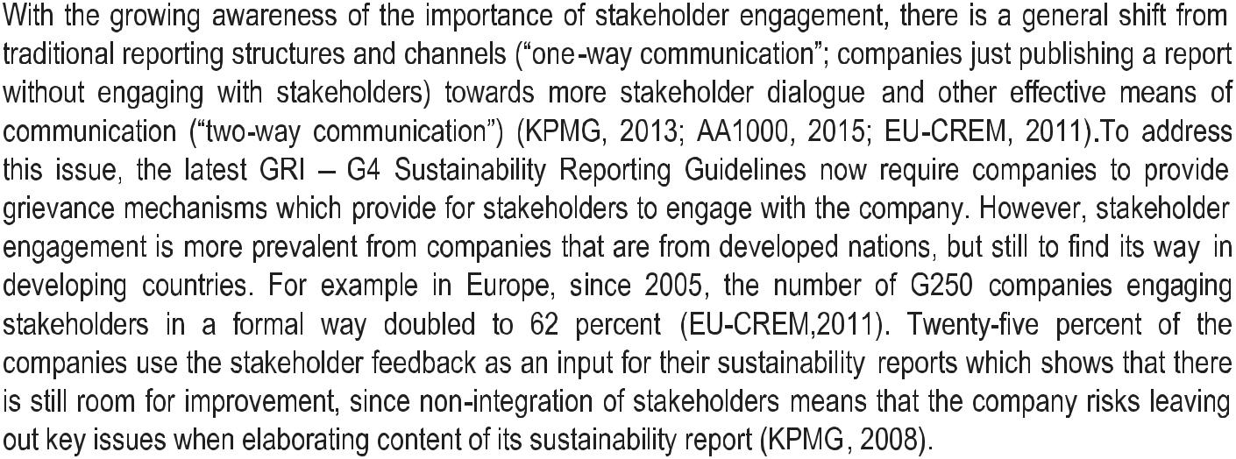
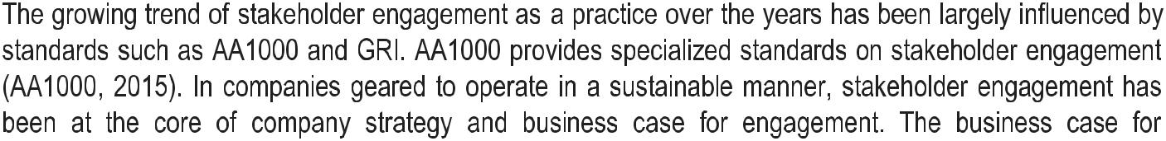
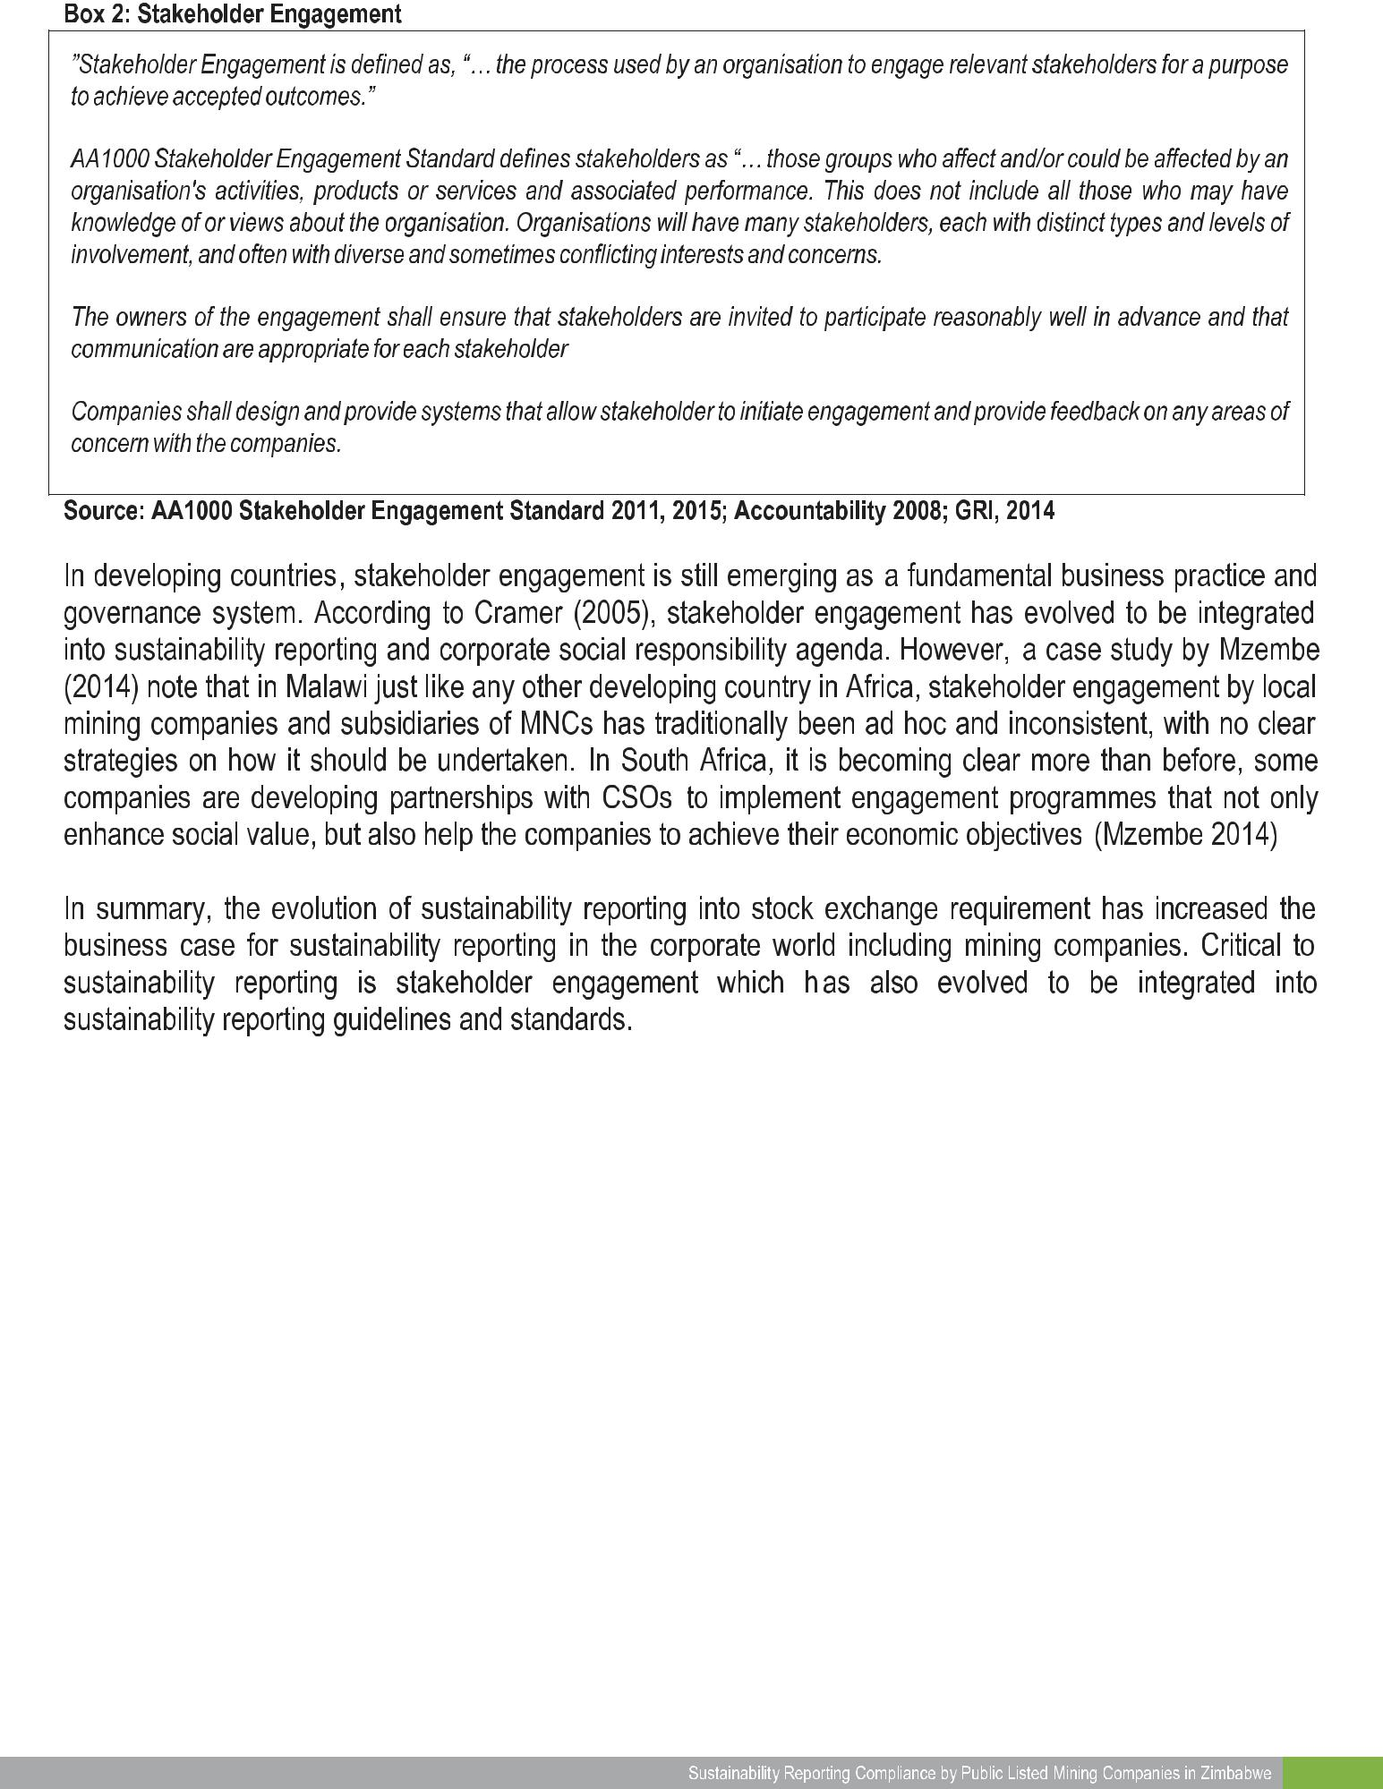

19

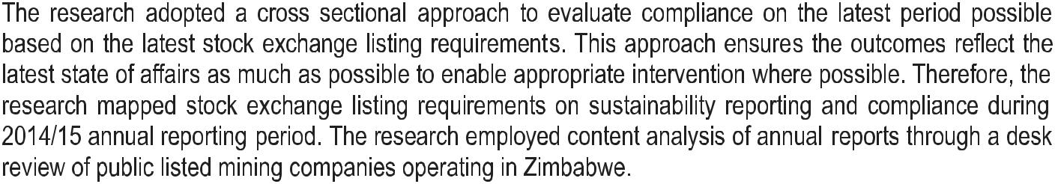
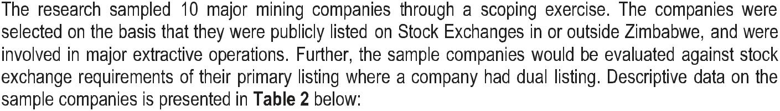
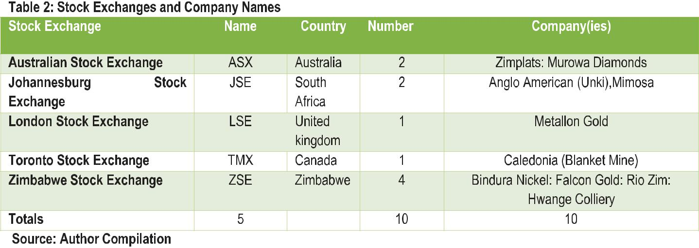
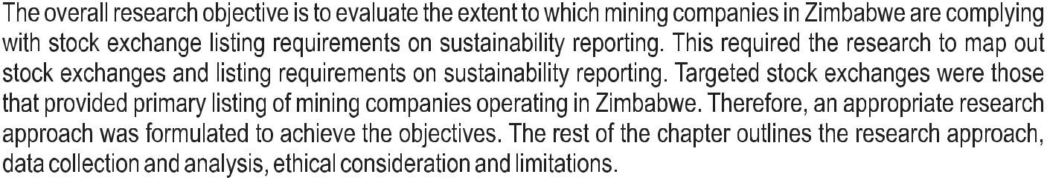
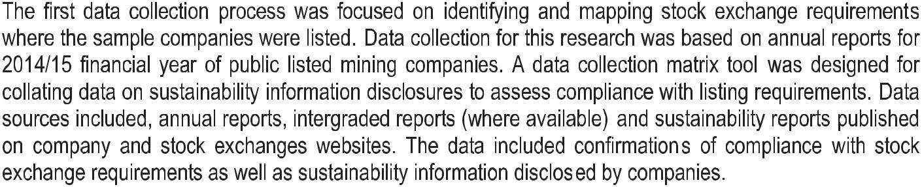
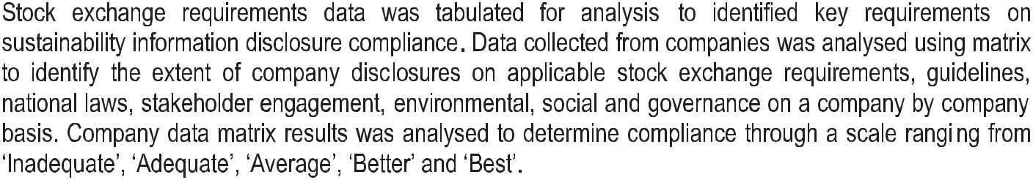
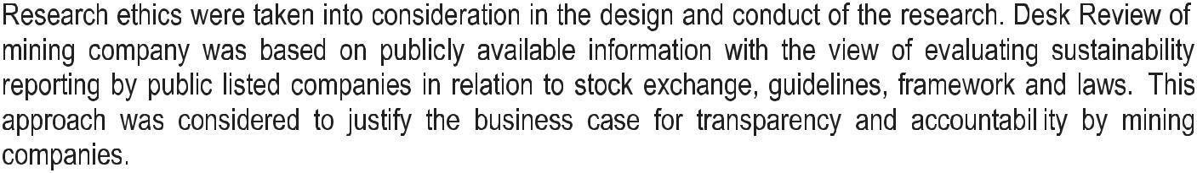

21

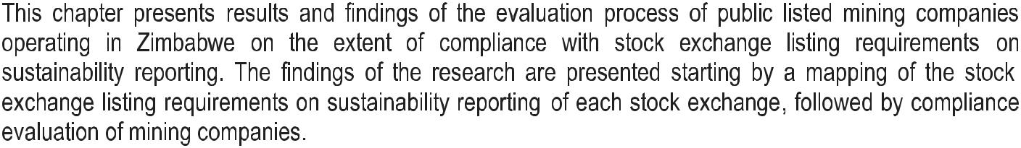

(See Box 4)
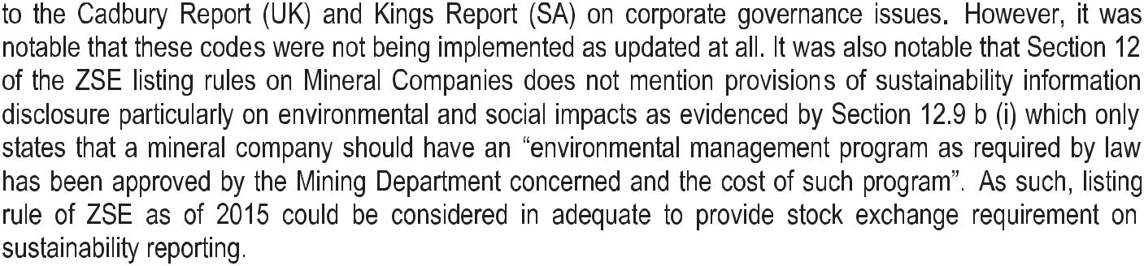
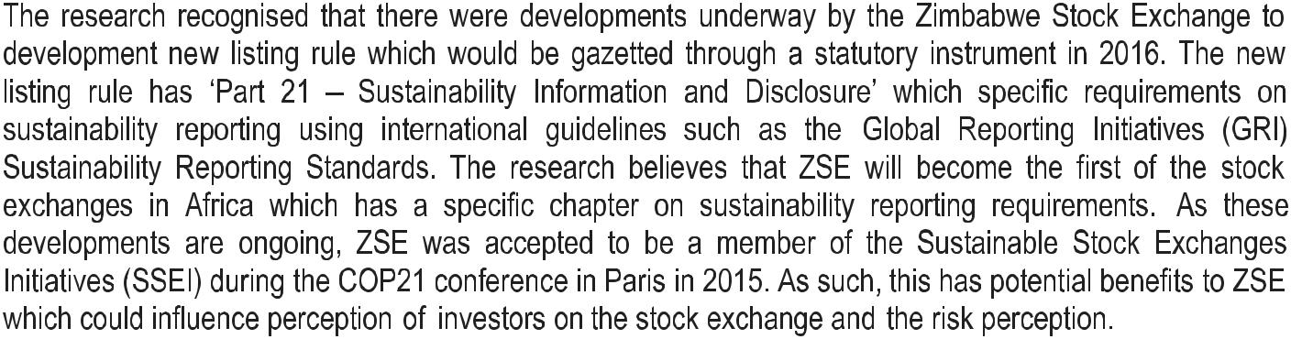
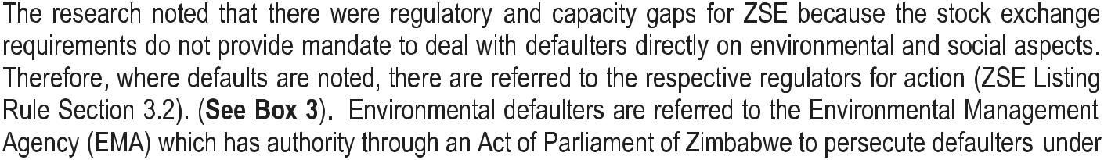
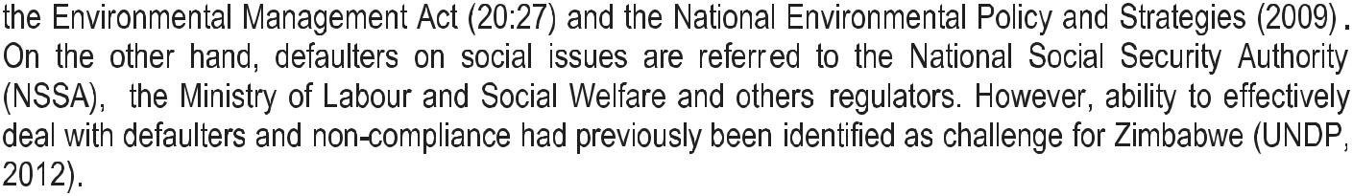
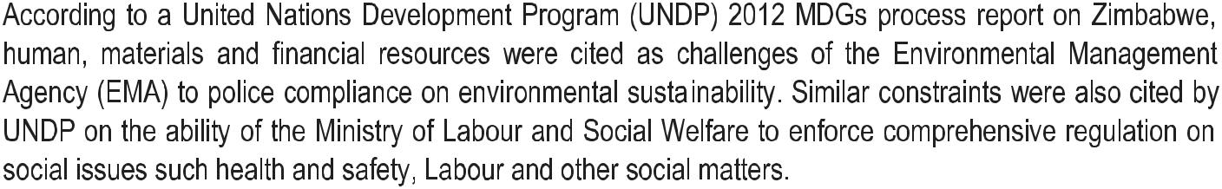

Box 3: Guidance on Overlaps between ZSE Listing Rules and other laws
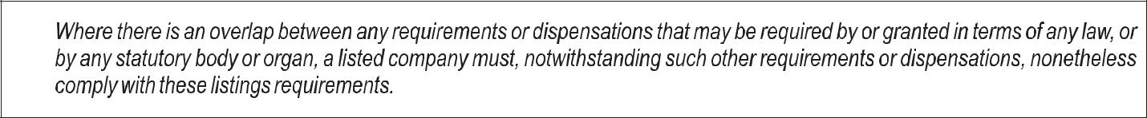
3.2.

Source: ZSE (2014) Listing Rules
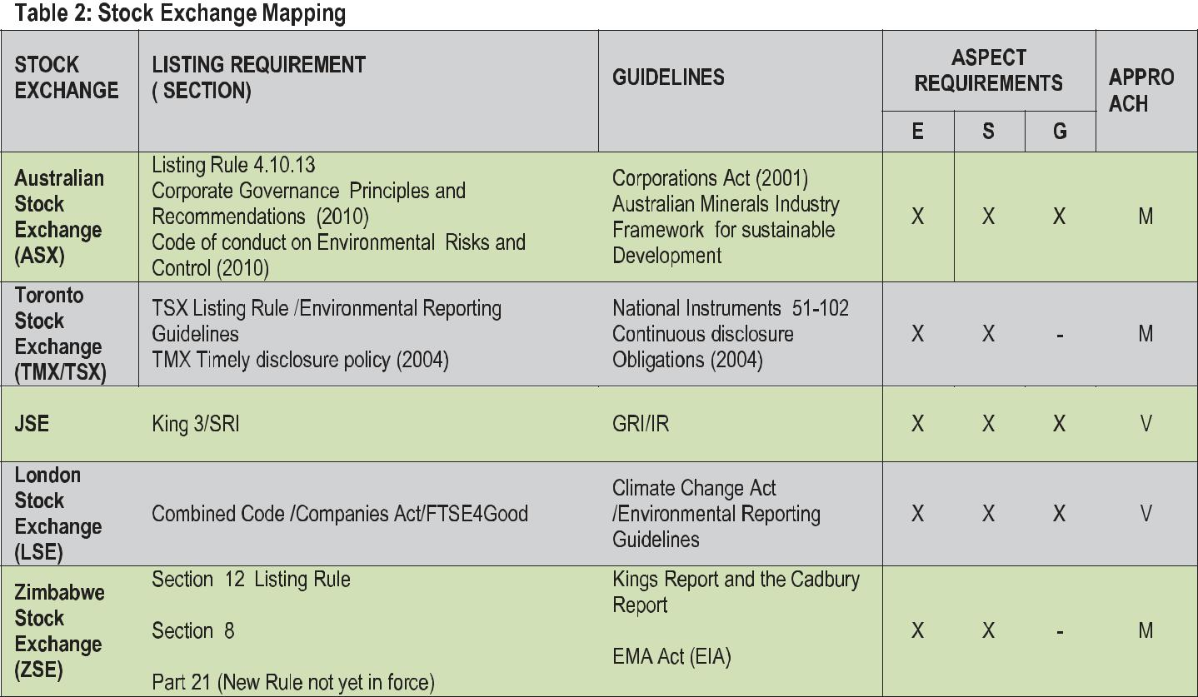

Source: Author Complications

23

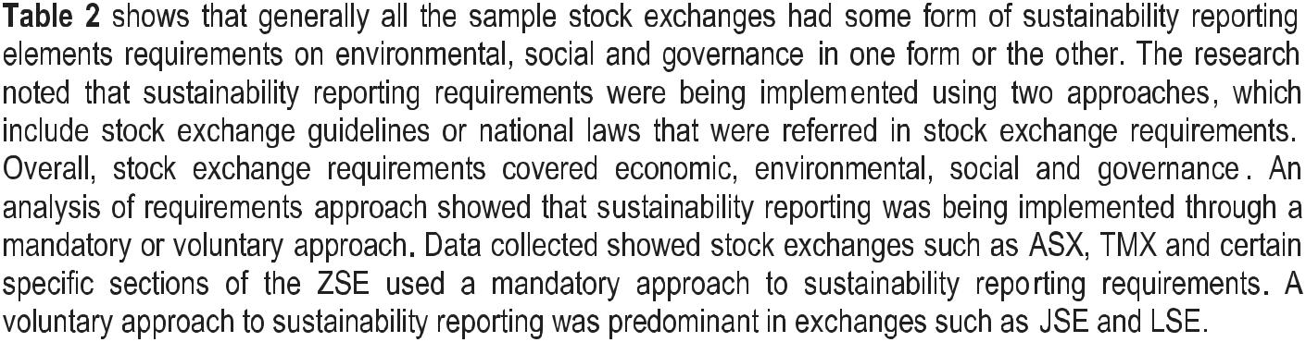
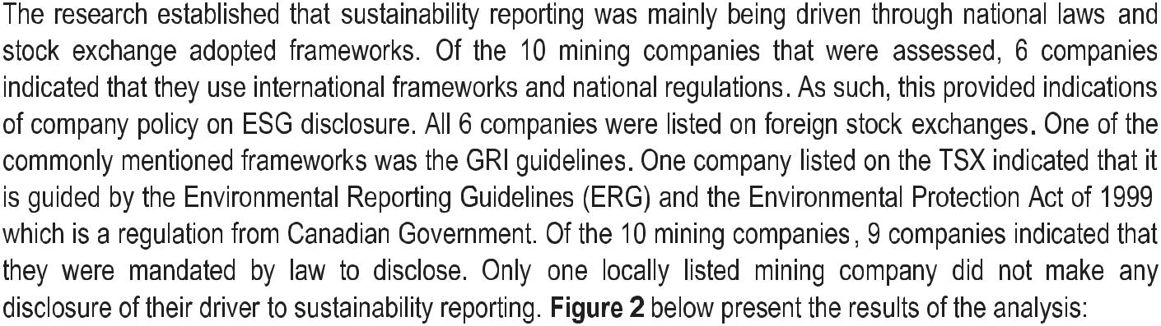
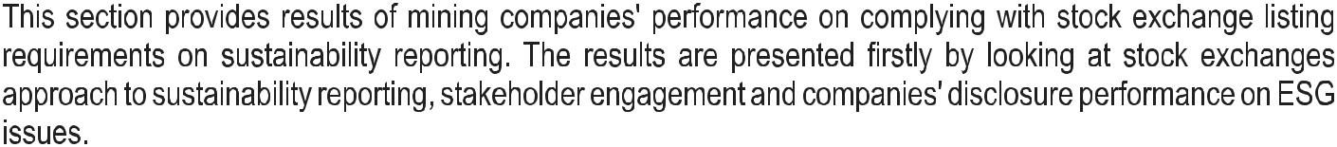

Figure 2: Sustainability Reporting Approach Performance
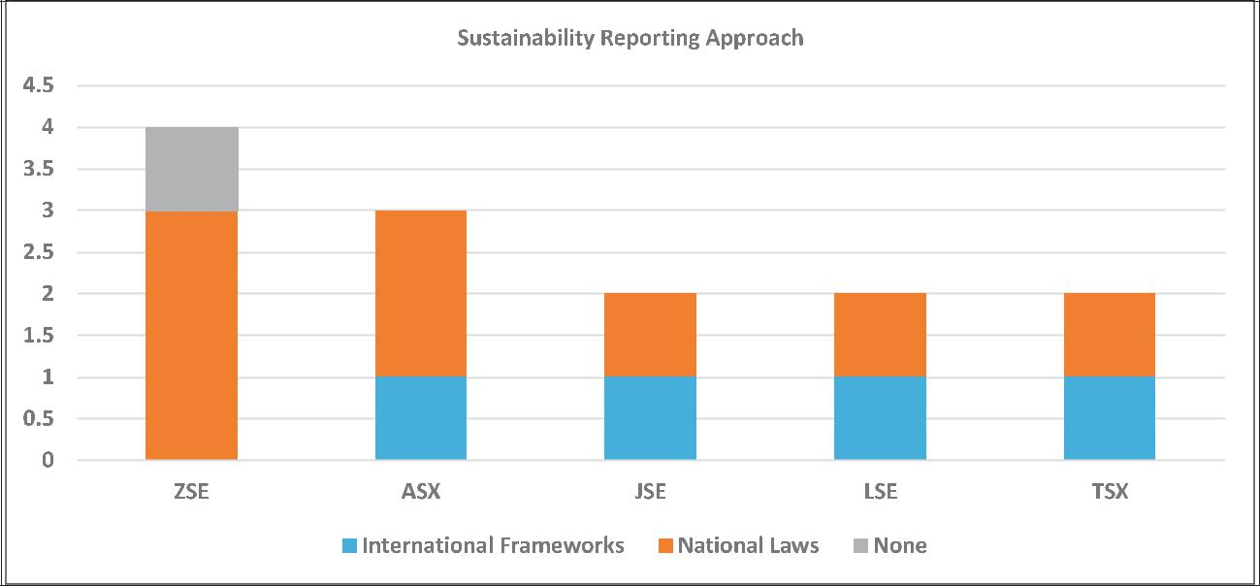

Source: Author Compilation

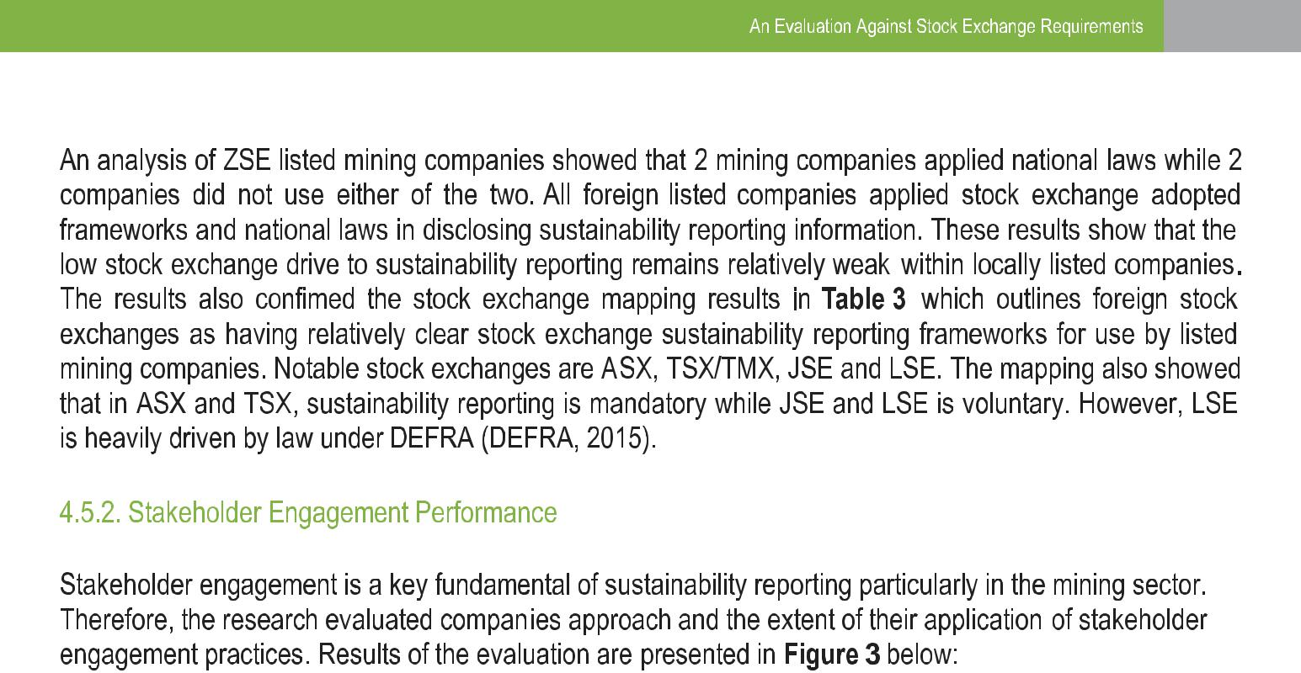

Figure 3: Stakeholder Engagement Approach and Performance
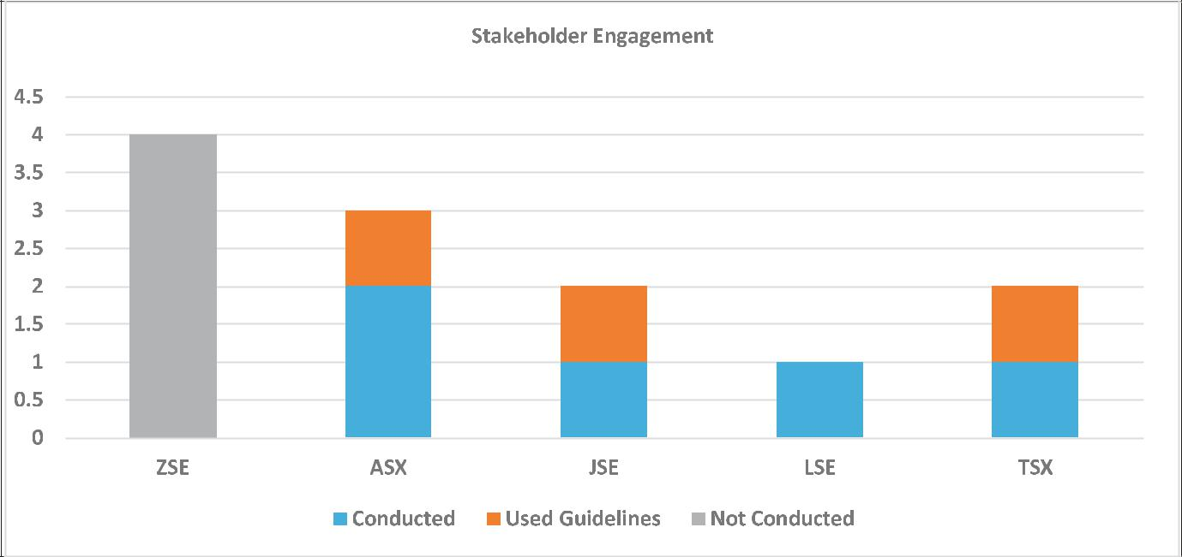

Source: Author Compilation

25

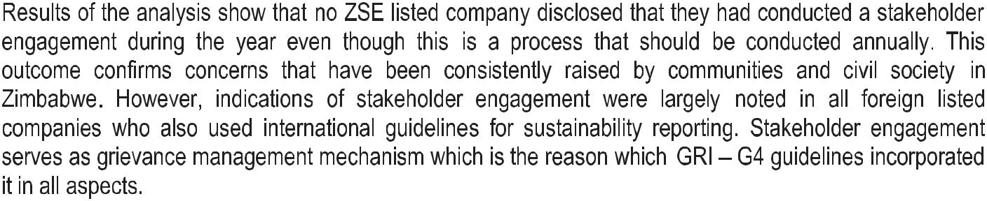
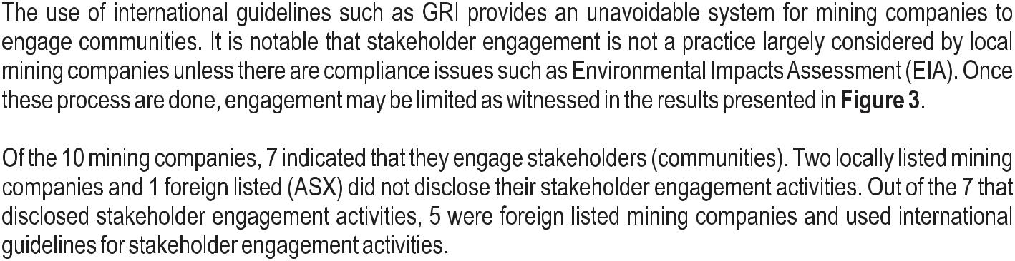

Table 3: ESG Aspects and Topics
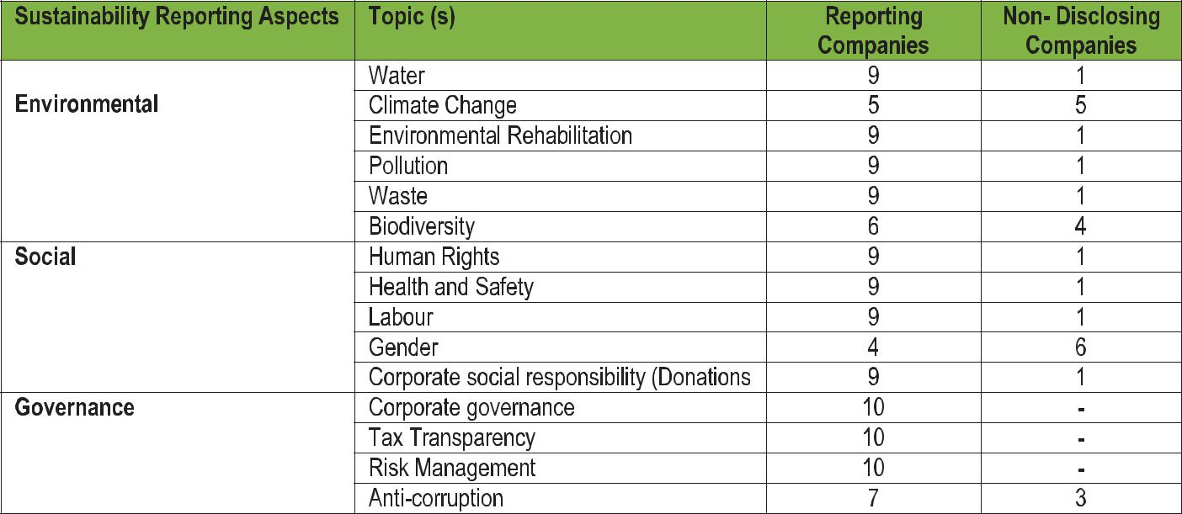

Source: Author Compilation
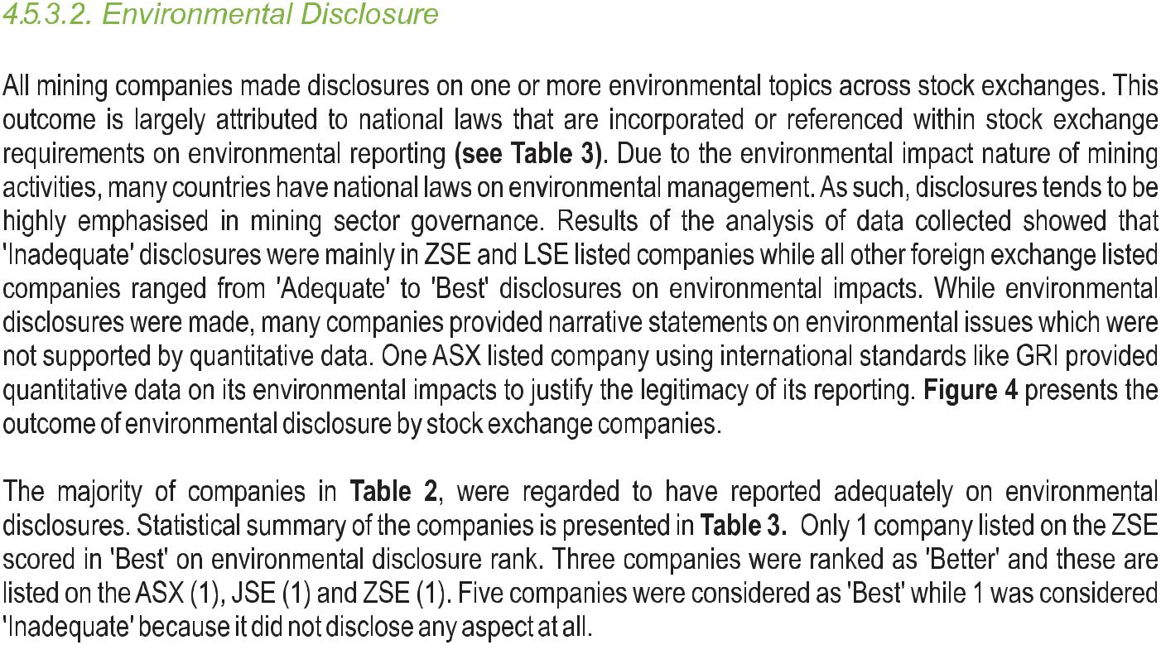

Figure 4: Environmental Disclosure Performance
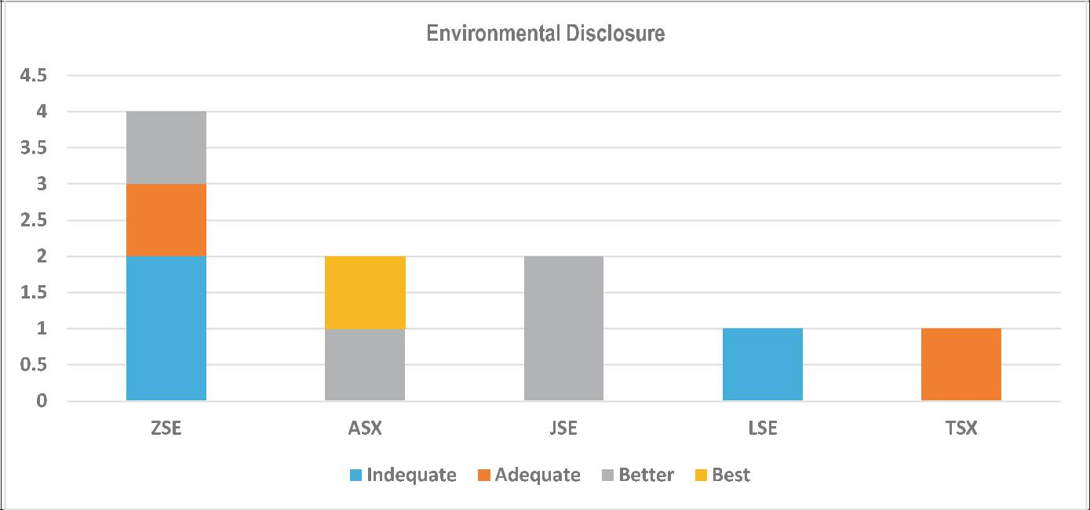

Source: Author Compilation

27

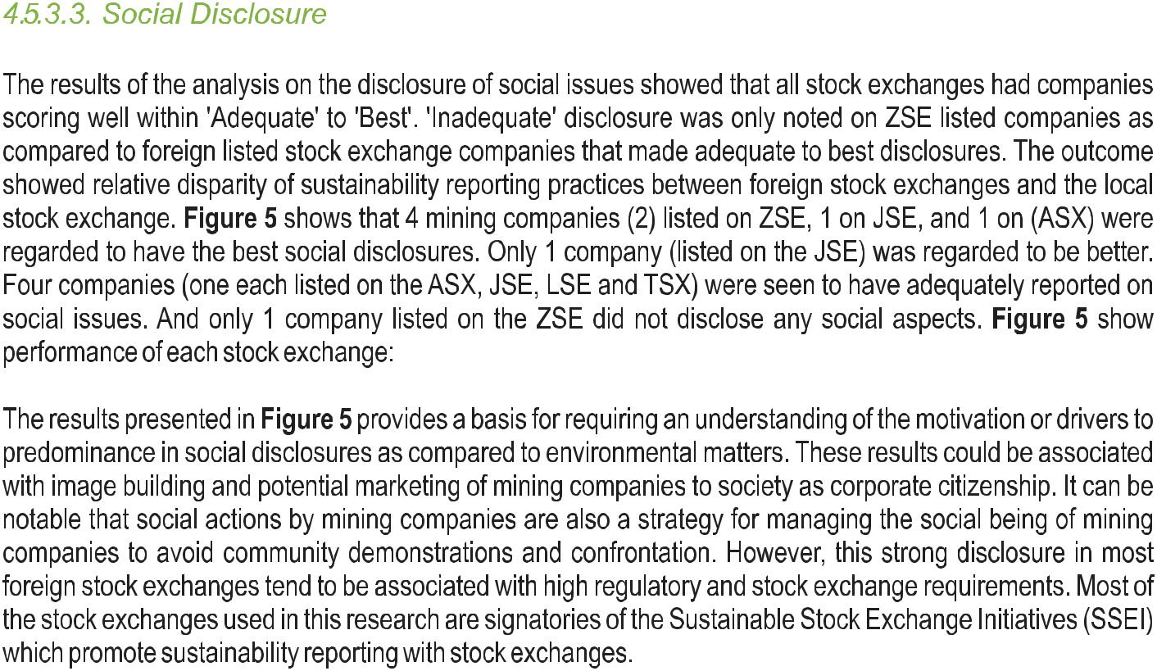

Figure 5: Social Disclosure Performance
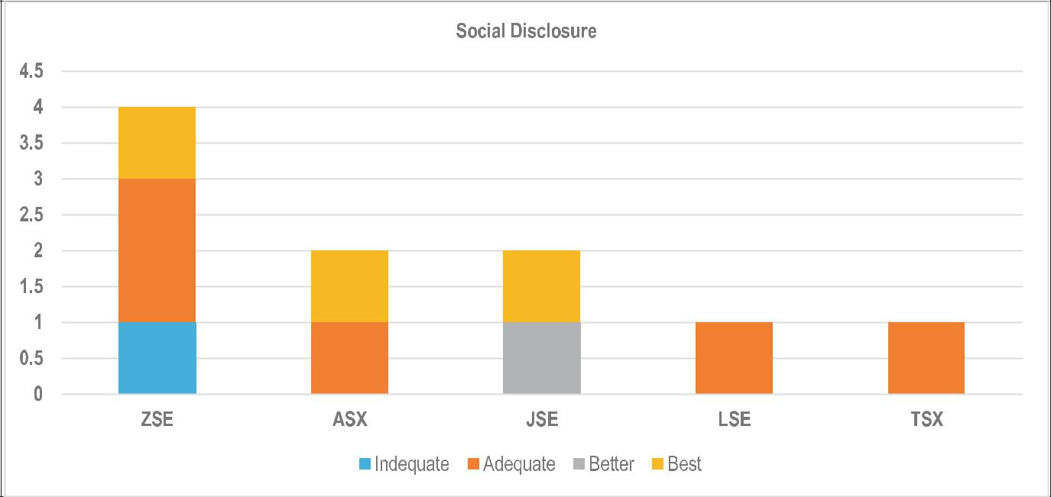

Source: Author Compilation
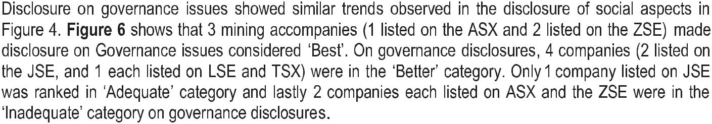

Box 4: ZSE Requirement on Corporate Governance
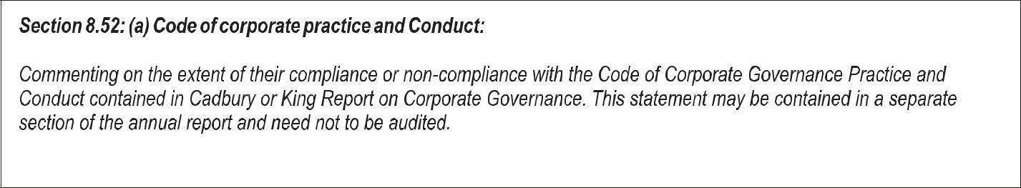

Source: ZSE Listing Rules as of 2014

Figure 6: Governance Disclosure Performance
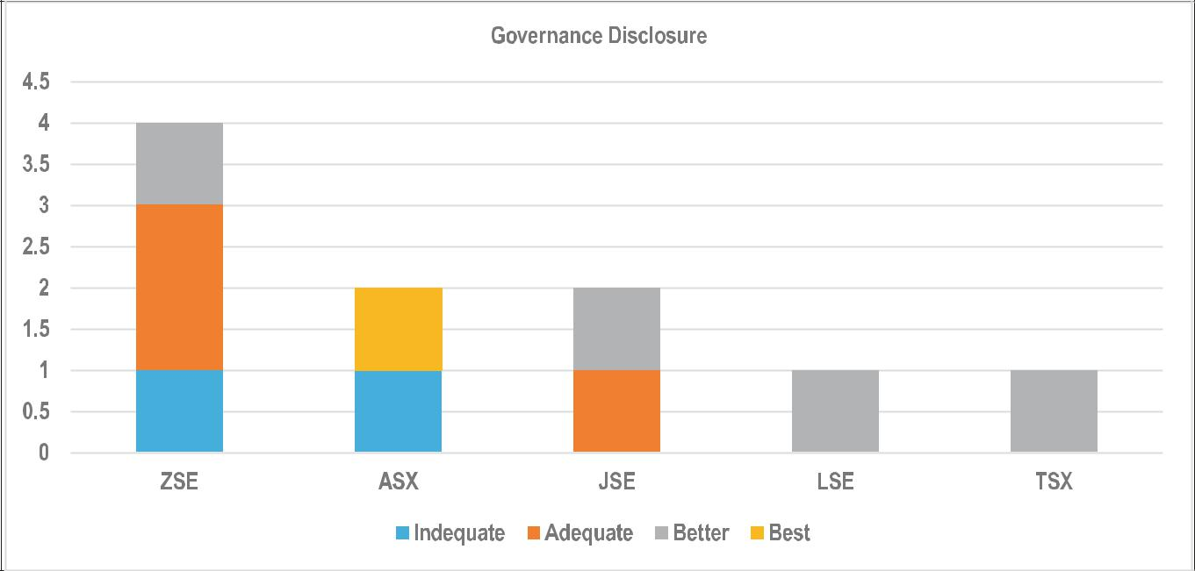

Source: Author Compilation

29

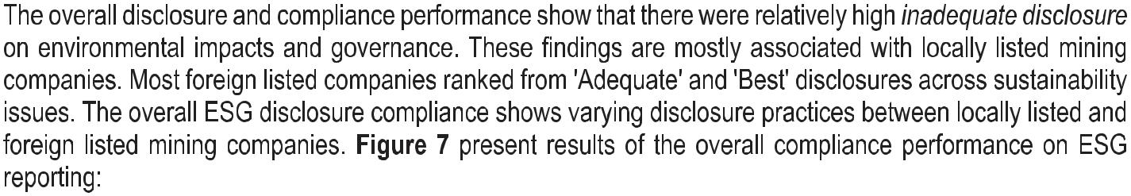

Figure 7: Overall ESG Reporting Performance
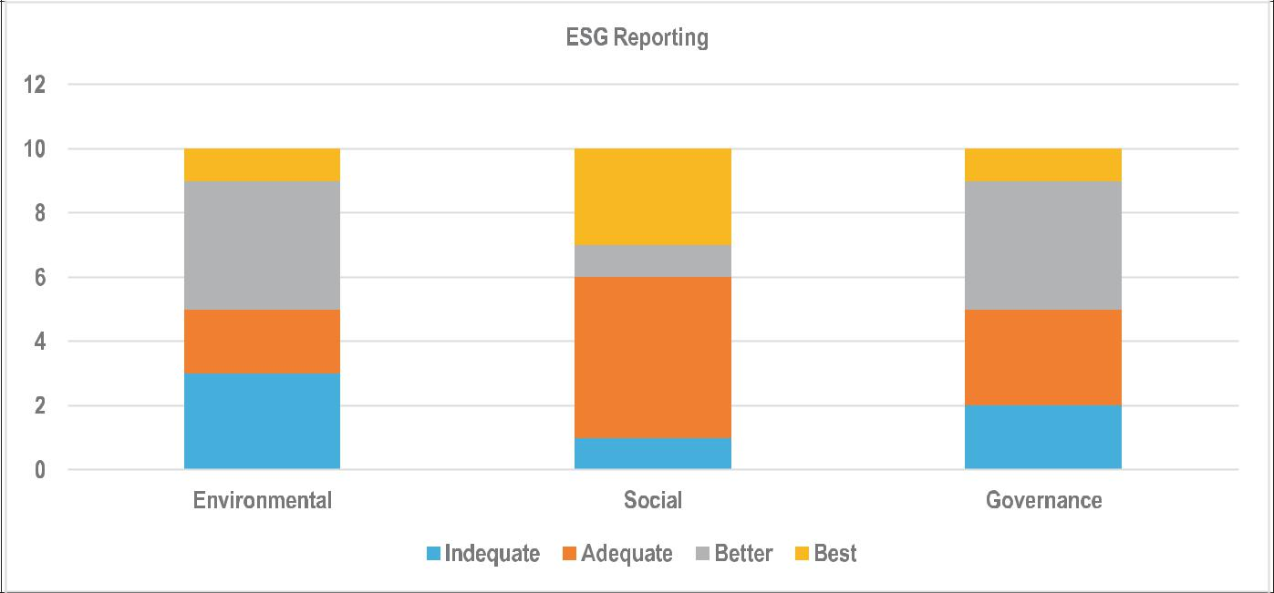

Source: Author Compilation
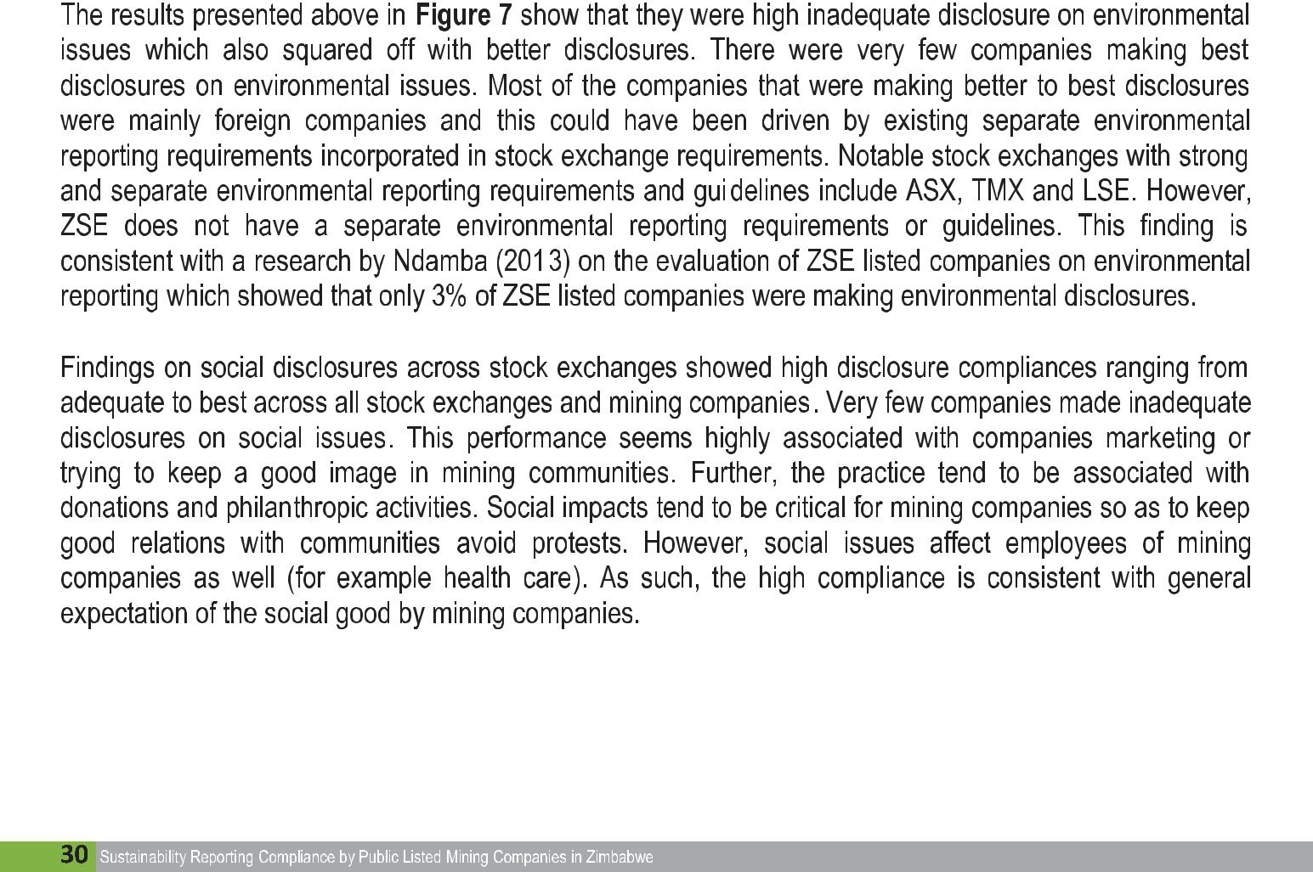
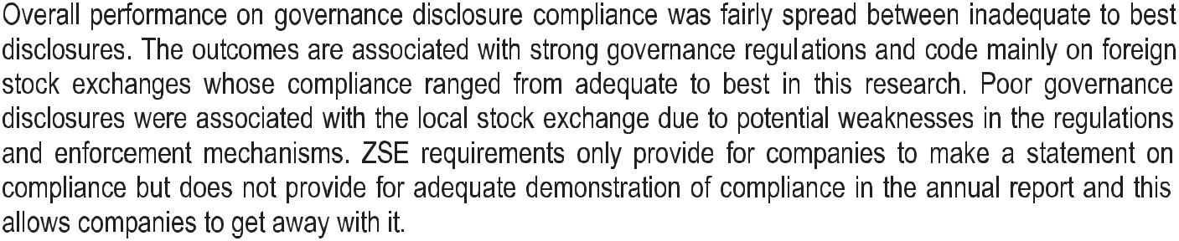
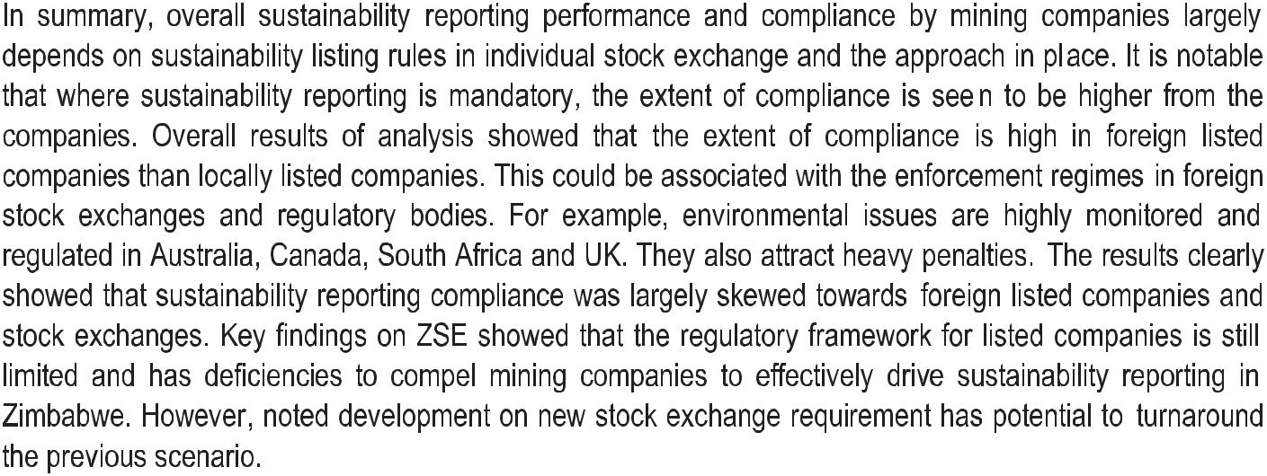

31

CONCLUSION
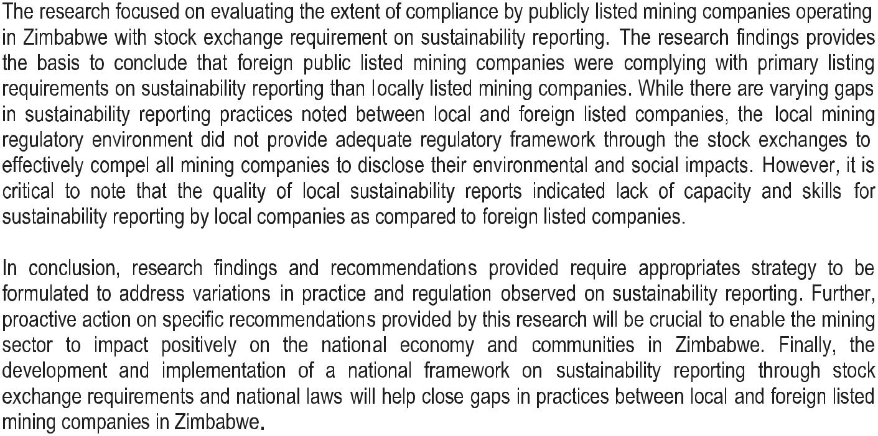

33

35

Institute for Sustainability Africa

22 Walter Hill Avenue, Eastlea, Harare

Tel: +263 8644109755 www.instforsustainafrica.org

